

TASK REPORT

**Create a static website hosted on Amazon S3.**

**Name : Addala Venkata Lakshmi Sravani**

Table of Contents

**Description** 2

**Introduction** 3

**Create an S3 bucket on AWS** 3

**Upload Website files to S3 Bucket 5**

**Setting up Static Web Hosting in S3 Bucket 6**

**Setting up Permissions in S3 Bucket 7**

**Accessing the Website Through URL 8**

**Description**

* Create a static website hosted on Amazon S3.
* Create a simple portfolio website using HTML and CSS, and host it on Amazon S3.
* Configure the necessary buckets, enable website hosting, and upload a basic HTML/CSS website.

**Introduction**

Amazon Simple Storage Service (Amazon S3) is an object storage service that offers industry-leading scalability, data availability, security, and performance. Customers of all sizes and industries can use Amazon S3 to store and protect any amount of data for a range of use cases, such as data lakes, websites, mobile applications, backup and restore, archive, enterprise applications, IoT devices, and big data analytics. Amazon S3 provides management features so that you can optimize, organize, and configure access to your data to meet your specific business, organizational, and compliance requirements.

**Create an S3 bucket on AWS**

* First login to your AWS management console and navigate to Amazon S3.
* Click on Create Bucket at the right corner of the S3 console:

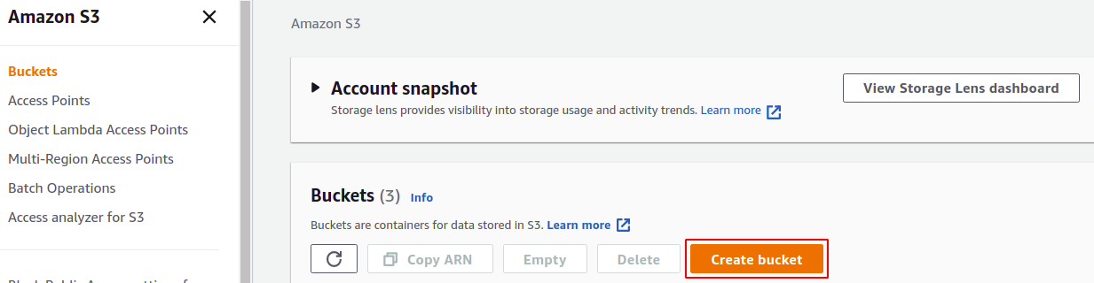

* Now provide a globally unique bucket name and choose appropriate region.
* Enable the access control lists(ACLs).

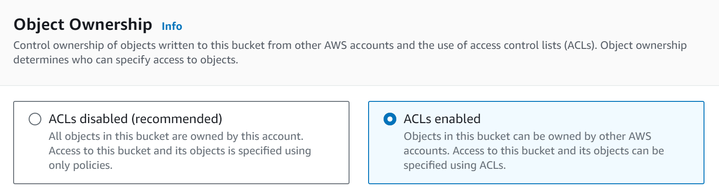

* Uncheck the Block all public access checkbox in the “Block Public Access setting for this bucket” section since we need the website to be accessible by everyone.

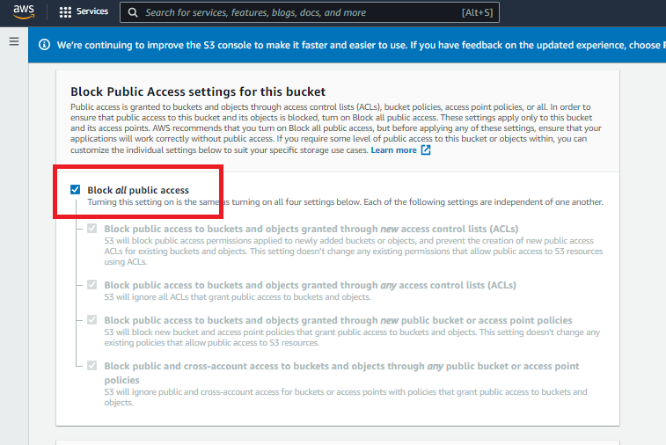

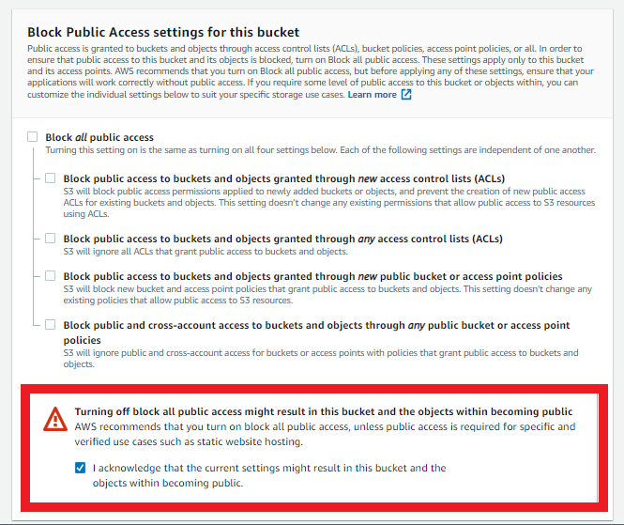

* Now just click on the **Create Bucket** button at the bottom right corner

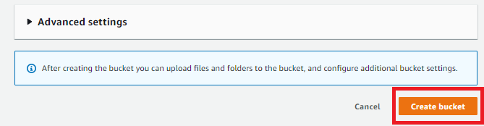

## Upload Website files to S3 Bucket

* Go to the **Objects** section, and then Click on the upload button to browse and upload required website files

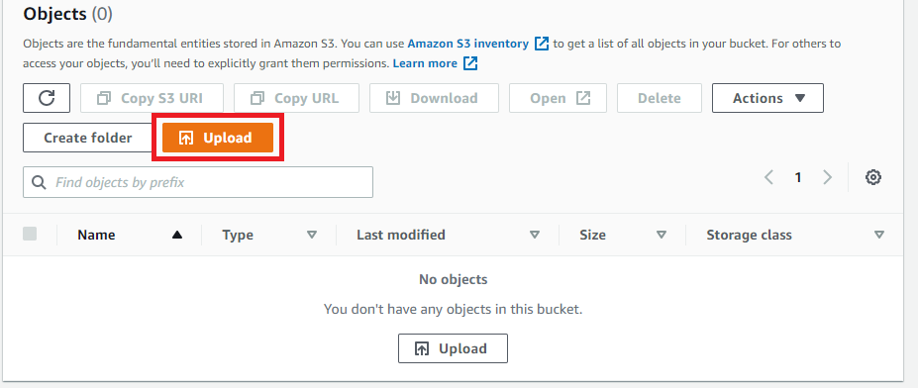

## 

## Setting up Static Web Hosting in S3 Bucket

* go to properties tab from the top menu in the S3 bucket to allow static web hosting.

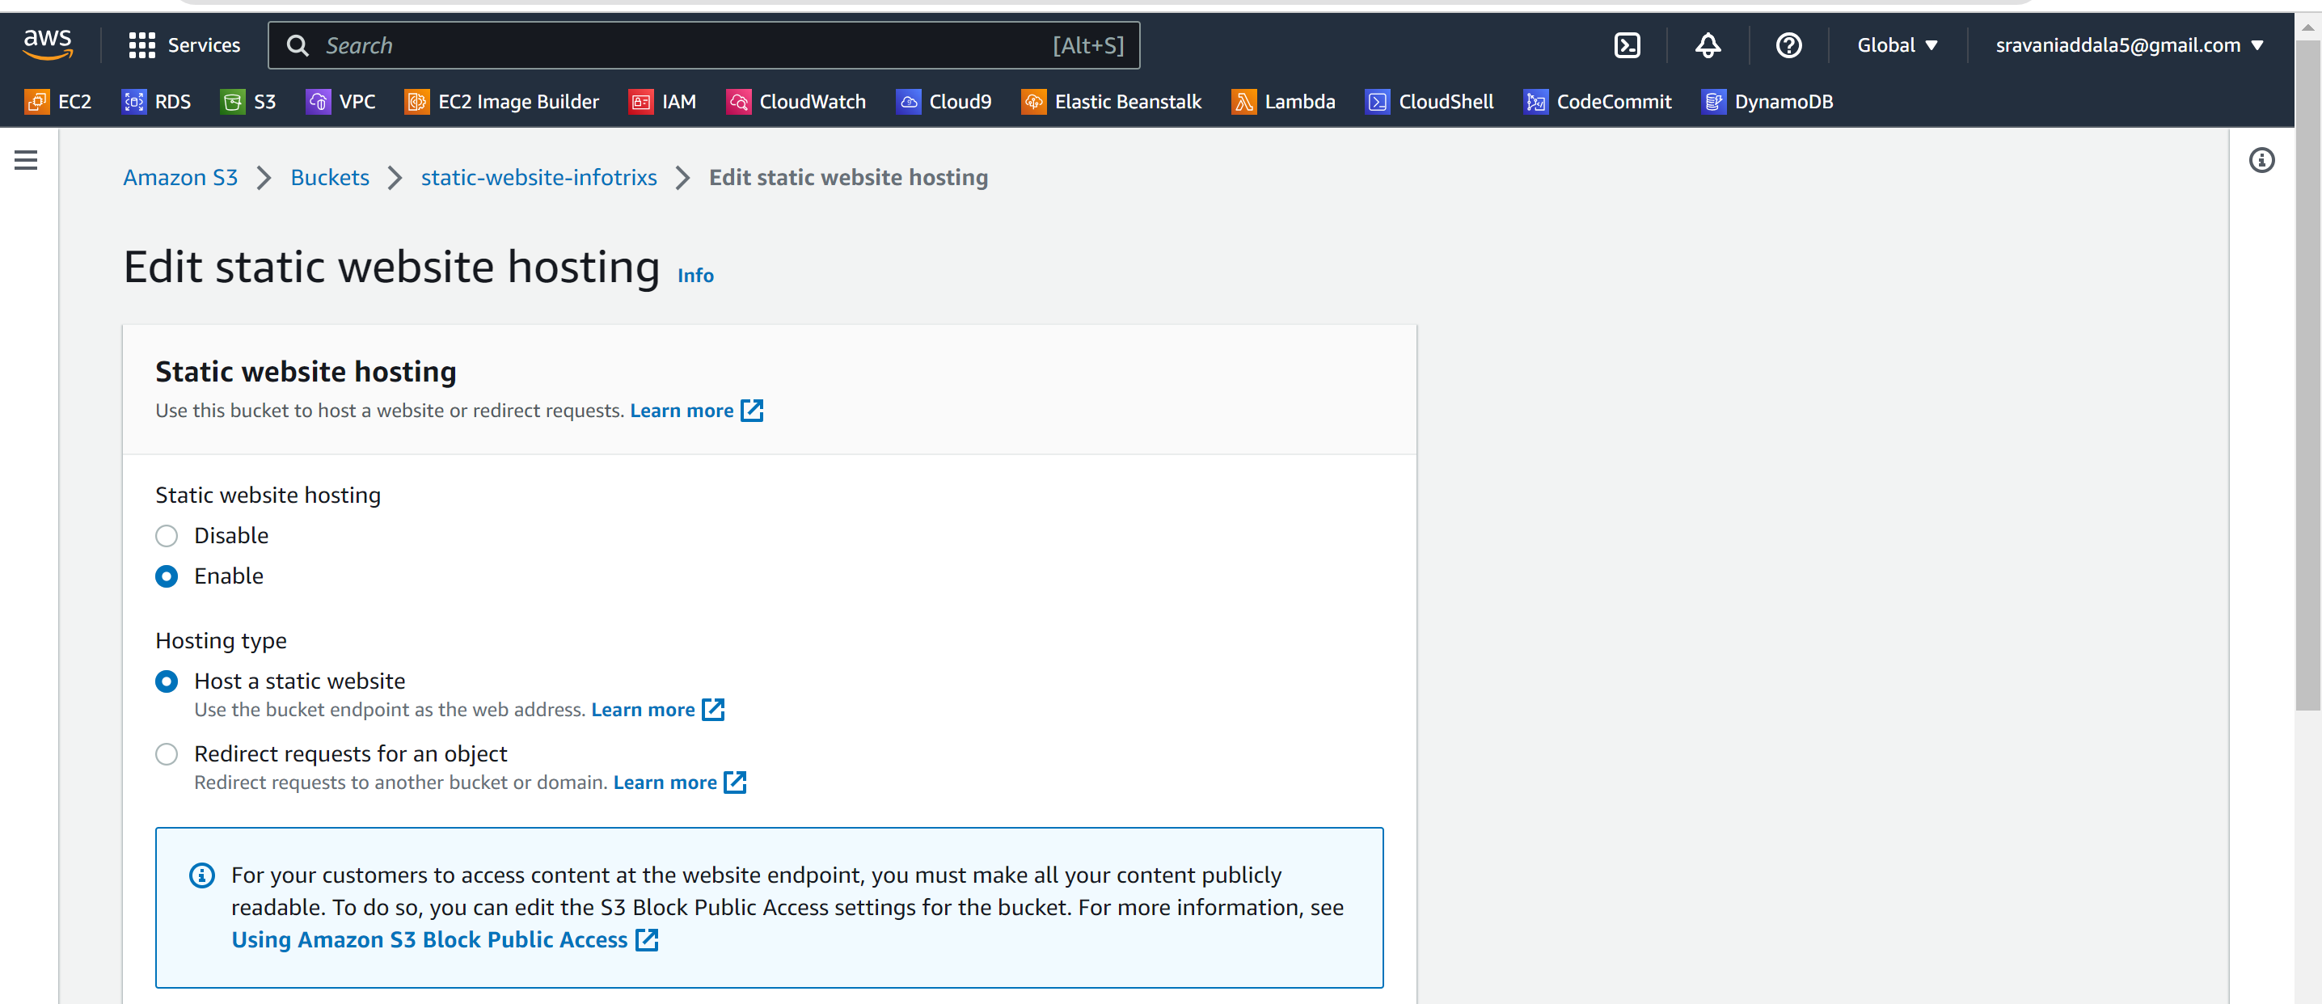

* Click on the Edit button in the Static website hosting section
* Enable the static web hosting reachable.
* Now give the name of Index Document ( Eg:-Website.html)
* click on the **Save changes** button to apply the changes to your S3 bucket

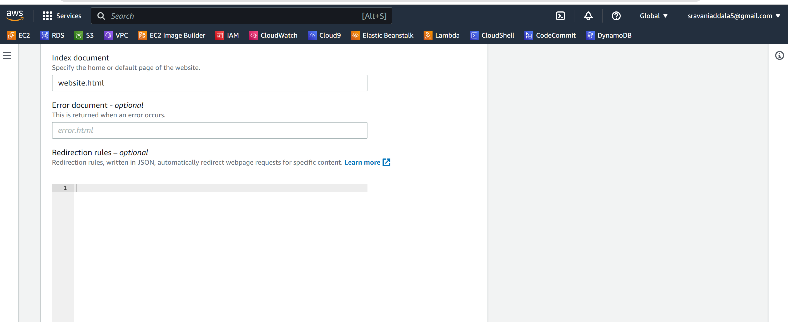

## Setting up Permissions in S3 Bucket

Configure the bucket and object permissions to allow public access.

Use a bucket policy or access control lists (ACLs) to grant read permissions to "Everyone" or "All Users."

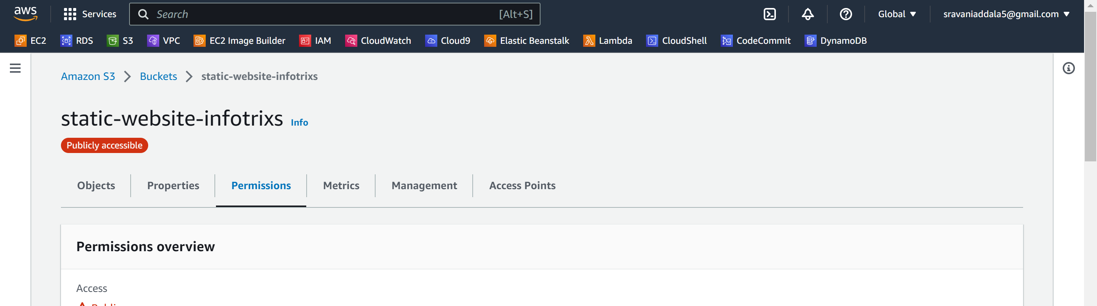

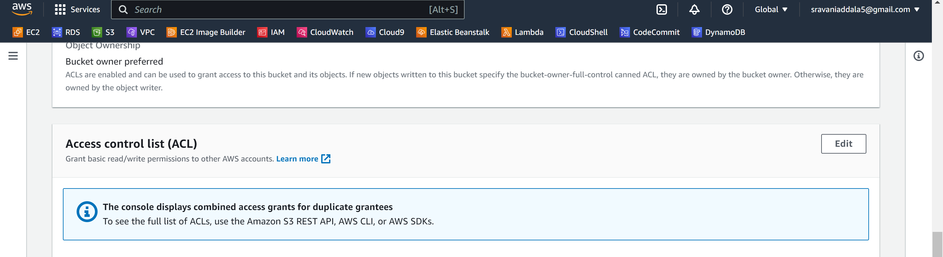

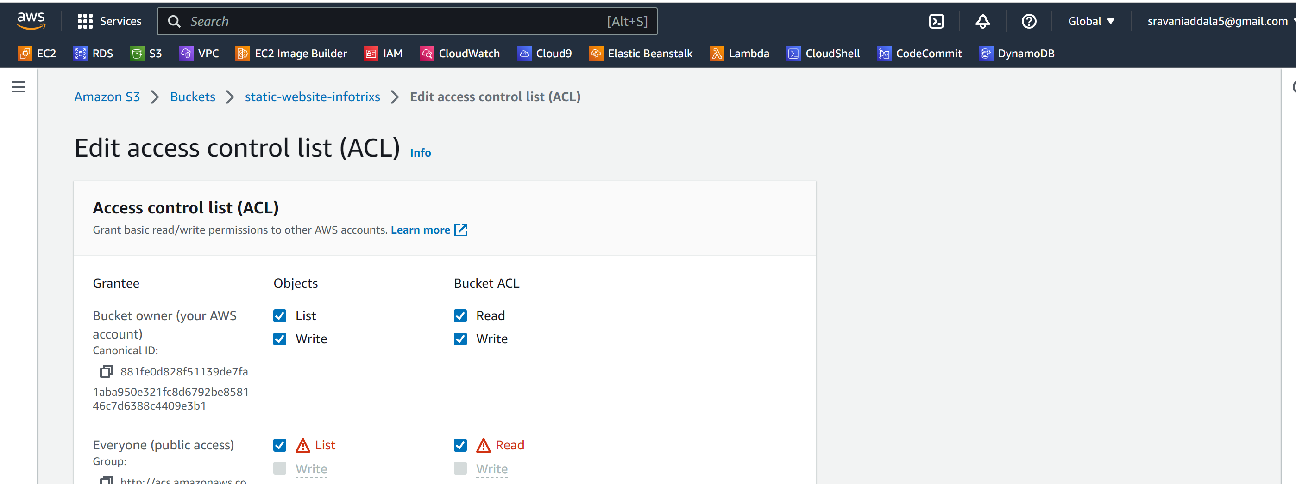

## Accessing the Website Through URL

* Now access the webpage through the URL.

